**PROCEDURE 1: KEFRI GRADUATE RESEARCH SCHOOL**

1. **Purpose**

The Purpose of this procedure is to ensure effective and efficient delivery of KEFRI Graduate Research School.

* 1. **Scope**

This procedure shall cover all students including local, national and international who are ready to undertake research in forestry and allied natural resources.

* 1. **Reference**

1. Current KEFRI Strategic Plan
2. ISO 9001:2015
3. ISO 14001:2015
4. Current KEFRI Service Charter
5. A Manual for Public Service Training
6. KEFRI current performance contracts
   1. **Terms, Definitions and Acronyms**
7. AC – Advisory Committee
8. DD – Deputy Director
9. DD FRSS – Deputy Director Forest Research Support Services
10. DD SCM – Deputy Director Supply Chain Management
11. GoK – Government of Kenya
12. KEFRI – Kenya Forestry Research Institute
13. KGRS-KEFRI Graduate Research School
14. RAC - Research Academic Committee
15. RD – Regional Director
16. RMPC – Resource Mobilisation and Partnership Committee
17. Stakeholder – KEFRI interested parties
18. TM – Training Manager
    1. **Responsibility**

The DD FRSS shall ensure adherence to this procedure.

1. **STEPS**

KGRS Coordinator/ TM, KGRS Secretariat and KGRS Operational committees shall coordinate the KGRS activities at various levels including; local, national and international as follows:

* 1. **Identification of Research Areas Procedures**

2.1.1. The Secretariat shall request for Research Needs and Gaps from Thematic DDs.

2.1.2. The Thematic DDs shall present Research Needs and Gaps in their respective themes to the Secretariat.

* 1. **KGRS Application Procedures**
     1. The KGRS Secretariat shall advertise call for research grant application on the KEFRI Website and any other relevant digital platform on annual basis.
     2. The Secretariat shall receive research grant applications both in hard and soft copy through [kgrs@kefri.org](mailto:kgrs@kefri.org) or director@kefri.org.
     3. The Secretariat shall forward Research Proposals from applications to the KGRS Coordinator/ TM.
     4. The KGRS Coordinator/ TM shall then forward proposals to RAC for vetting.
     5. The RAC shall then forward selected proposals to AC for approval of funding.
     6. The KGRS Council shall award research grants as approved by AC.
     7. The KGRS Council shall authorise KGRS Coordinator/TM to invite the approved research grant awardees/students.
  2. **Proposal Funding Procedures**
     1. The RAC shall forward approved Research Proposals to Thematic Area DDs for funding.
     2. The DDs shall fund the Research Proposals for implementation.
     3. The students shall receive approved research funds through the RDs where the research shall be carried out.

**3.0. APPLICABLE RECORDS**

3.1. Call for Research Grant Applications

3.2. Research Proposal Application Form.

3.3. Students Progress Report Form.

3.4. Research Supervision- Student Tracking Record Form.

3.5. KGRS Annual Summary List of Students Database

KEFRI/F/KGRS/01



**KEFRI GRADUATE RESEARCH SCHOOL (KGRS)**

**Call for Research Grant Applications**

**Masters and PhD Research Programmes in Forestry and Allied Natural Resources**

P.O. Box 20412 - 00200 Nairobi. KENYA Telephone +254722157414/+254734251888

E-mail: [director@kefri.org](mailto:director@kefri.org) Website: [www.kefri.org](http://www.kefri.org)

| **KENYA FORESTRY RESEARCH INSTITUTE (KEFRI)**  **GRADUATE RESEARCH GRANT**  **YEAR**  **CLOSING DATE:** |
| --- |

| **ABOUT KEFRI** |
| --- |
| Kenya Forestry Research Institute (KEFRI) is a State Corporation established in 1986 under the Science and Technology Act Chapter 250 of the Laws of Kenya to undertake research in forestry and allied natural resources. The Act was repealed through the Science, Technology and Innovation Act No. 28 of 2013 and operationalised by the Forest Conservation and Management Act 2016 in the Ministry of Environment and Forestry.  As a world class centre of excellence in forestry and allied natural resources research for sustainable development, KEFRI is well endowed with a professional human capital with an established well-coordinated institutional structure and networks that ensures strong linkage between scientists and stakeholders at national, regional and international levels.  The Institute is mandated to conduct research in forestry and allied natural resources; disseminate research findings to stakeholders; build capacity of stakeholders; and establish partnerships and cooperate with other research organisations and institutions of higher learning in joint research and training. KEFRI’s research and development agenda is mainly funded by the Government of Kenya, internal funds and key development partners. |

| **ABOUT KGRS** |
| --- |
| KGRS is a deliberate strategic, transformational, and skills-oriented policy intervention that KEFRI has embraced to unlock its research potential and efficiency by providing **shared space or platform** for scientists, scholars and young graduates **to translate ideas into actions and impact.** This initiative is expected **to link** research to practice and industry/ job market and provide evidence based solutions to sustainable forestry development in Kenya and beyond. KGRS is an equal opportunity initiative  To date, KGRS has a total of 40 on-going research students with an equal proportion of 20 each on PhD and MSc programmes. Of the 40 students, 90% are KEFRI scientists registered in different institutions of higher learning in Kenya (35) and Belgium (1) on either a PhD or MSc study programme. Four (4) non-KEFRI scientists are benefitting from the Research grant award after our first intake for the year 2020-2021, following a competitive application.  **KGRS Vision**  A centre of excellence in **delivering high-quality personnel** in forestry and allied natural resources for sustainable development.  **KGRS Mission**  To **provide a platform** for strategic, transformational and practical skills-oriented solutions through research in forestry and allied natural resources for socio-economic development.  **KGRS Philosophy**  **Working effectively** at the **interface** of Education, Training and Research.  **Aim**  KGRS has been embraced by KEFRI as a way of **enhancing the momentum** and **linking research** of strategic institutional and national importance **with appropriate scientific responses** that would **provide sustainable measures to address felt-needs** and emerging concerns in forestry and allied natural resources.  **Broad Objective**  To enhance institutional forestry research output through **building and linking practical experience and competency of stakeholders to industry**.  **Specific Objectives**   1. Support for research initiative. 2. Propel institutional transformation linking education, research, experience and industry. 3. Build capacity of the future and potential research scientists. 4. Promote scientific outreach. 5. Enhance collaboration with partner institutions. |

| **ELIGIBILITY CRITERIA** |
| --- |
| To be eligible, an applicant must provide evidence of:   1. Being a Kenyan Citizen. 2. Being under the age of 35 years for Masters and 45 years for PhD research programmes. 3. Being a holder of a Bachelor’s Degree in forestry and allied natural resources, at the level of Upper Second Class Honours from a reputable institution of higher learning, to be considered for a Masters’ Programme. 4. Being a holder of a Master’s Degree in forestry and allied natural resources from a reputable institution of higher learning, in order to be considered for the PhD Programme. 5. Being presently fully registered as a post graduate student in an institution of higher learning. 6. Having completed any Course work as per the requirements of the institution of higher learning in which one is registered with, for which they can provide evidence of outstanding achievement. 7. Being ready to prepare and present a written research proposal as outlined in the attached format and within specified thematic areas in forestry and allied natural resources currently being; Forest productivity and improvement, Forest biodiversity and environmental management, Forest products development, Socio-economics, policy and governance. 8. A proposal developed within the context of KEFRI Strategic Plan 2018-2022, paying particular attention to the research gaps that are yet to be covered by the respective thematic area as **attached (Annex 1).** 9. Being willing and committed to completing their research work within a period of between 6-9 months under joint supervision of their institution of higher learning and qualified KEFRI scientists.   Accepted students will be required to sign a Letter of Commitment with KEFRI, governing their conduct while working and associated with the Institute. |

| **FIELDS OF STUDY** | |
| --- | --- |
| MSc and PhD programmes will draw broadly from thematic areas in the current KEFRI Strategic Plan 2018 - 2022. Research areas will include studies in: | |
| * + Tree breeding   + Silviculture (soft and hardwoods)   + Forest resources inventory   + Climate change   + Forest ecology   + Forest management   + Dryland forestry technologies   + Forest pathology   + Forest entomology   + Forest economics, marketing and trade   + Wood and non-wood forest products | * + Forest hydrology   + Forest certification   + Tree seed science   + Forest restoration   + Forestry extension (adoption of technologies)   + Forest socio-economic, policy and governance   + Forest and woodland fires   + Forest soil health |

| **RESEARCH GRANT AWARD** |
| --- |
| The Research Grant **Award covers cost of**:   1. Research and academic resources as defined by the approved study requirements.   The Research Grant **Award WILL NOT cover**   1. Tuition fees. 2. Monthly allowance to support living expenses. 3. Book allowance, however any text books or software procured will remain KEFRI property.   Applicants must complete all research work within the Research Grant period as such provision cannot be extended other than under **exceptional** circumstances. |

| **METHOD OF APPLICATION** |
| --- |
| The applicants should submit their duly completed formal application in soft and hard copies which should include the following:   1. Completed application form 2. Concise curriculum vitae with names and contacts of at least two referees. 3. Certified copies of academic certificates and transcripts 4. Certified copies of national Identity Card 5. Copy of admission letter from the institution of higher learning one is registered. 6. Two (2) Reference Letters with contact addresses. 7. **Research Proposal Application Form** is as **attached (Annex 2)** in word format. |
| **CONTACT ADDRESS** |
| Applicants must scan and produce electronic copies of all the above documents (**converted to PDF format**) and send to the following e-mail address.  [**director@kefri.0rg**](mailto:director@kefri.0rg) copied to [**kgrs@kefri.org**](mailto:kgrs@kefri.org)  In addition, a set of hard copies of the above documents and a recent passport-size photograph must be sent by post to the following address:  **Director/Chief Executive Officer**  **Kenya Forestry Research Institute (KEFRI)**  **P.O. Box 20412-- 00200**  **Nairobi, Kenya**    **Closing date:** |

**KEFRI/F/KGRS/02**



**KEFRI GRADUATE RESEARCH SCHOOL**

**Research Proposal Application Form**

| **GUIDELINES**   |  | Criteria for consideration:   * + - * *For it to be eligible, this proposal application form MUST be accompanied by a Letter from your Board of Graduate Studies/School as a proof the proposal has been defended and approved.* * *Only original works should be submitted, plagiarism is highly discouraged and if confirmed, will lead to automatic disqualification.* * *KEFRI encourages co-funding of research. Any aspect of your research that is being funded by other donor(s) should therefore be disclosed.* * *Applicants who have* ***on-going*** *funded projects are not eligible.* * *Applications should be submitted in both* ***soft*** *and* ***hard*** *copies.* * *This programme is open to Masters and Doctoral students from forestry-related disciplines of specialization from both public and private Universities.* * *Opportunities also exist for applicants with requests to contribute in funded research that fits within KEFRI's mandate.* * *Any applications submitted after the specified deadlines have lapsed will not be considered.* | | --- | --- | | |
| --- | --- | --- | --- |
| **Applicant details (*Registered MSc. and Ph.D Students only*)** |
| Surname: ___________________________________ |
| Given name (s) ______________________________________________Gender: ____________________ |
| Nationality ___________________________: Country:_________________________________________ |
| National ID/Passport Number:**_________________________________** (*Attach a copy*)  University: _____________________________________________________________________________  Faculty/School: _________________________________________________________________________  Department:__________________________________________________________________________  University registration/admission No.:___________________ Highest qualification:___________________  University Supervisor(s):___________________________Contact:_________________________________ |
| **Current contacts:**  E-mail: ______________________________________Mobile phone No.:____________ |
| Postal address: _______________________________ Postal Code:_________________ |
|  |

(*Expand the spaces provided in the form below to fit. The proposal should not exceed* ***20 pages***, *Times New Roman font size 12, single spacing*, *excluding relevant appendices e.g. CV, letter of approval from Board of Postgraduate, workplan, etc.)*

| **1. Title of your Research:** |
| --- |
| **2. Area of specialization**: |
| **3. Abstract:** (*Maximum of 300 words*)  **Six (6) Key words:** |
| **4. Give a brief background to the proposed research. Provide relevant and updated literature review related to your proposed research to show the existing gaps.** |
| **5. Define the problem that the proposal seeks to address, stating the justification of the project** |
| **6. State the objectives of your research**  **Overall objective**  **Specific objectives** |
| **7. State your hypothesis/research questions if any.**   1. **.** 2. **.** |
| **8. State clearly the expected outputs of this research and ensure that they are linked with the stated objectives**   1. **1** |
| **9**. **Identify clearly the potential beneficiaries of the research results and the expected impacts.** |

**10. Research Design and Data Analysis**

| **10.1 Describe the research Methodology** *(Provide clear descriptions of the scientific methodologies you will use in this research, indicating statistical methods, experimental designs and analysis to be used etc). Ensure you clearly indicate the methodologies to be used to achieve the stated objective.* |
| --- |
| **10.2 Identify and list any specialised equipment, facilities and infrastructure, which are required for the project.** |

**11. Project Work Plan**

**11.1. Detailed Plan of Activities**

Provide a clear indication of the tasks that will be performed to complete the work in the following format. (*Attach the workplan separately*).

**12 Facilities and Funding**

| **12.1** | **List facilities relevant to the research project that are available at your University**  **1.** | | |
| --- | --- | --- | --- |
| **12.2 List any other funds that you or your institution have obtained or will apply for towards financing this particular research project** | | | |
|  | Donor | Timeframe | Amount (Ksh.) |
|  |  |  |
|  |  |  |

| **12.3 If you have Co-funding for your project, please give details of the funding you have received and why this Grant is needed.** |
| --- |

**13.0 Budget Estimate**

**(*NOTE that institutional overheads or charges, administration fee are not accepted under this grant. Emphasis on budget allocation should be placed on expendable supplies.* (***This Grant does not support the acquisition of:- Laptops; Desktop Computers; Printers; Cameras; Mobile phones, Payment of tuition fees, Salaries, Consultancies fees, Subscription fees*). *Any equipment procured will remain property of KEFRI.*

*Provide clearly itemised Quarterly budget. You can add rows to this template to fit list of your budget items (The budget MUST not include any of the above-mentioned items).*

| **Budget Items** | **Quantity** | **Cost/Unit** | **Quarter 1**  **Amount (Ksh.)** | **Quarter 2**  **Amount (Ksh.)** | | **Quarter 3**  **Amount (Ksh.)** | | **Quarter 4 Amount (Ksh.)** |
| --- | --- | --- | --- | --- | --- | --- | --- | --- |
| **13.1. Expendable supplies (***to be procured through KEFRI procurement procedures***)** | | | | | | | | |
|  |  |  |  |  | |  | |  |
|  |  |  |  |  | |  | |  |
|  |  |  |  |  | |  | |  |
|  |  |  |  |  | |  | |  |
|  |  |  |  |  | |  | |  |
| **Sub-total (Ksh.)** | | |  |  | |  | |  |
| **13.2. Equipment** *(Specify and describe each item) Equipment normally found in KEFRI Labs and field Centres may not be supported by this grant* | | | | | | | | |
|  |  |  |  |  | | |  |  |
|  |  |  |  |  | | |  |  |
|  |  |  |  |  | | |  |  |
|  |  |  |  |  | | |  |  |
|  |  |  |  |  | | |  |  |
|  |  |  |  |  | | |  |  |
| **Sub-total (Ksh.)** | | | **-** | **-** | | |  |  |
| **13.3 Documentation, publication costs, conferences** | | | | | | | | |
| Printing/binding thesis |  |  |  |  |  | | |  |
| Conference presentations and posters |  |  |  |  |  | | |  |
| Research Permit (NCST) |  |  |  | - | - | | |  |
| Journal(s) publication |  |  |  |  |  | | |  |
| **Sub-total (Ksh.)** | | |  |  |  | | |  |
| **Annual budget (Ksh.)** | | |  |  |  | | |  |
| **Total amount applied (Ksh.)** |  | | | | | | | |
| ***Total budget Applied for MUST not exceed the Advertised limit. Any applications exceeding the limit will not be considered. (MSc. and Ph.D maximum budget is Ksh 1,000,000 and 2,000,000, respectively)*** | | | | | | | | |

| **13.4 List the items you requested funding for in the budget, describing their function, explain their cost, and justifying their use in this research (***Attach clear explanatory notes of the budget***).**   | **Equipment/Reagent** | **Function** | **Justification** | **Study objective** | | --- | --- | --- | --- | |  |  |  |  | |  |  |  |  | |  |  |  |  | |  |  |  |  | |  |  |  |  | |
| --- | --- | --- | --- | --- | --- | --- | --- | --- | --- | --- | --- | --- | --- | --- | --- | --- | --- | --- | --- | --- | --- | --- | --- | --- |

| **14. References** (*List all publications/literature materials cited in this application using APA system*) |
| --- |

| **15. Supervisors**  (*Provide updated contacts of all supervisors:- Name, Institution, Telephone and E-mail*). Note that KEFRI will also assign a supervisor to handle the research process as accredited by the participating university. |
| --- |

**16. Appendices**

**The following documents MUST be attached to your application.**

1. *Letter from Board of Postgraduate Studies/School to prove the proposal has been defended and approved.*
2. *Copies of BSc and MSc Degree certificate(s).*
3. *Letter of admission from your University.*
4. *Copy of National ID/Passport.*
5. *Letter of Affiliation from a local Institution (Those registered outside the Country)*
6. *Brief CV (2-3 pages)*
7. *Proposed Work plan.*

| **Contact**  **Director**  Kenya Forestry Research Institute (KEFRI)  P.O. Box 20412 - 00200 Nairobi. KENYA Telephone +254722157414/+254734251888  E-mail: [director@kefri.org](mailto:director@kefri.org) Website: [www.kefri.org](http://www.kefri.org)  OR  E-mail: kgrs@kefri.org |
| --- |

**NOTE:**

1. KEFRI **DOES NOT** CHARGE A FEE AT ANY STAGE OF ITS SELECTION PROCESS INCLUDING APPLICATION, AWARD OF RESEARCH GRANT AND PROCESSING OF OFFER LETTER. THE PROPOSALS WILL BE RATED ACCORDING TO THEIR QUALITY BASED ON THE ATTACHED CRITERIA.
2. RESEARCH GRANT IS **NOT APPLICABLE** IN CASE OF SELF-SPONSORED STUDENTS.
3. SELF-SPONSORED STUDENTS MAY APPLY TO USE THE PLATFORM THROUGH **PARTNERSHIP** ARRANGEMENTS.

KEFRI/F/KGRS/03



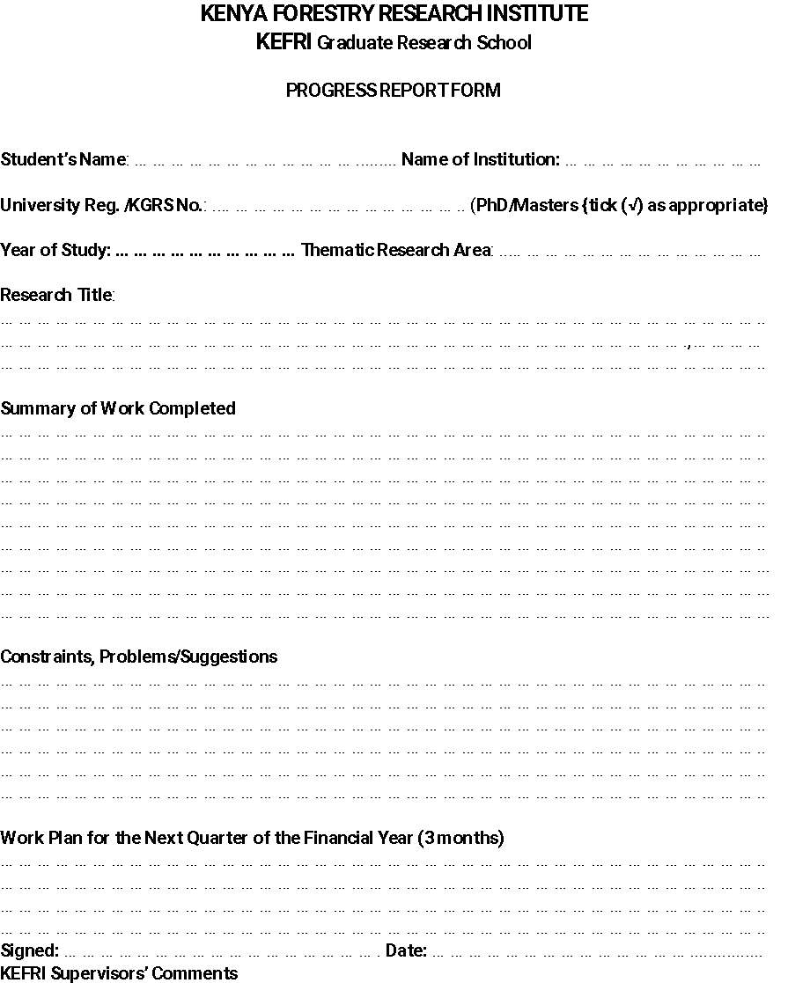

KEFRI/F/KGRS/04



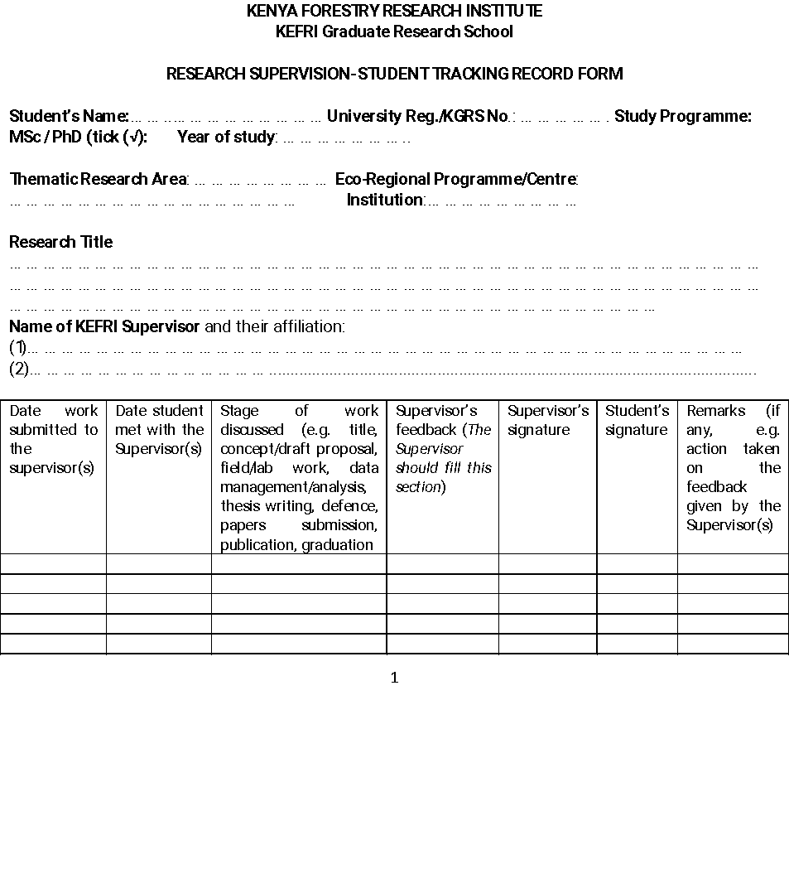

**KEFRI/F/KGRS/05**



**KEFRI GRADUATE RESEARCH SCHOOL (KGRS)**

**ANNUAL SUMMARY OF STUDENTS DATABASE**

**PhD Programme**

|  | **Name (P/N)** | **Thematic area/Centre** | **Registered**  **Course/Degree** | **Research Focus/ KEFRI Supervisor (KS)** | **Research Concept Title** | **Institution of Higher Learning** | **Status** (*include any publications*) | **Year of Study** | **Expected year of completion** | **Research Cost (Ksh)** |
| --- | --- | --- | --- | --- | --- | --- | --- | --- | --- | --- |
| 1. |  |  |  |  |  |  |  |  |  |  |
| 2. |  |  |  |  |  |  |  |  |  |  |
| 3. |  |  |  |  |  |  |  |  |  |  |
| 4. |  |  |  |  |  |  |  |  |  | 0 |
| 5. |  |  |  |  |  |  |  |  |  |  |

**Masters’ Programme**

| **No.** | **Name (P/N)** | **Thematic area/Centre** | **Registered**  **Course/Degree** | **Research Focus/KEFRI Supervisor** | **Research Concept Title** | **Institution of Higher Learning** | **Status** | **Year of Study** | **Expected**  **year of completion** | **Research**  **Cost (Ksh)** |
| --- | --- | --- | --- | --- | --- | --- | --- | --- | --- | --- |
| 1. |  |  |  |  |  |  |  |  |  |  |
| 2. |  |  |  |  |  |  |  |  |  |  |
| 3. |  |  |  |  |  |  |  |  |  |  |
| 4. |  |  |  |  |  |  |  |  |  |  |
| 5. |  |  |  |  |  |  |  |  |  |  |

**Research Grant Awardees (External Students)**

|  | **Name** | **Gender** | **Programme**  **(PhD/MSc)** | **Institution of Current Study** | **Programme Registered** | **Study Title** | **Area of Specialization/ KEFRI Supervisor (KS)** | **KEFRI Thematic Area** | **Status**  **(***include any publications***)** |
| --- | --- | --- | --- | --- | --- | --- | --- | --- | --- |
| 1**.** |  |  |  |  |  |  |  |  |  |
| 2 |  |  |  |  |  |  |  |  |  |
| 3. |  |  |  |  |  |  |  |  |  |
| 4. |  |  |  |  |  |  |  |  |  |